**Sixteen points, six lines**

You are requested to draw six thin continuous straight lines passing through sixteen points in a square lattice as shown below.

**(1)** You must not lift up your pen when drawing.

**(2)** The starting point must also be the ending point.

**(3)** You must give at least two possible solutions. Note that rotation or reflection of your solution is considered to be the same solution.

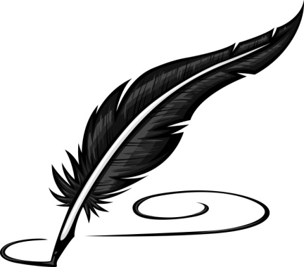

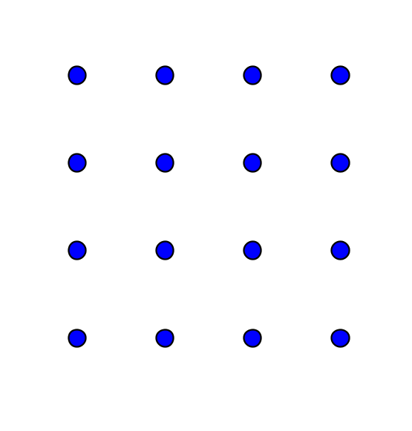

**Answers:**

I have got 4 solutions. There may be others.

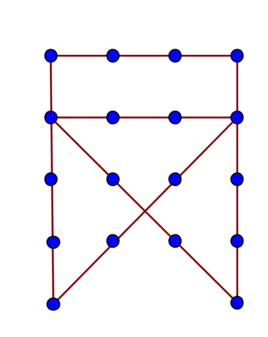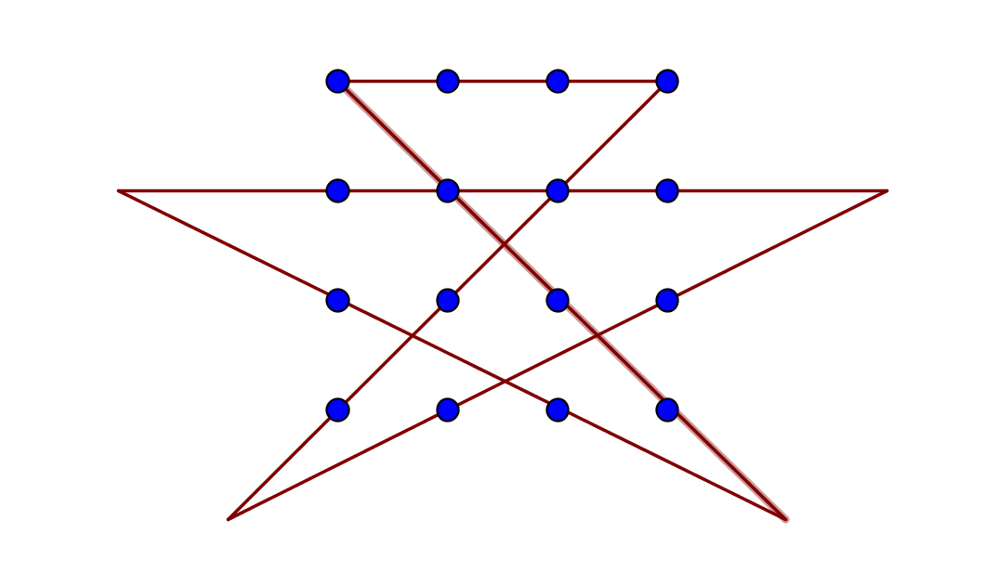

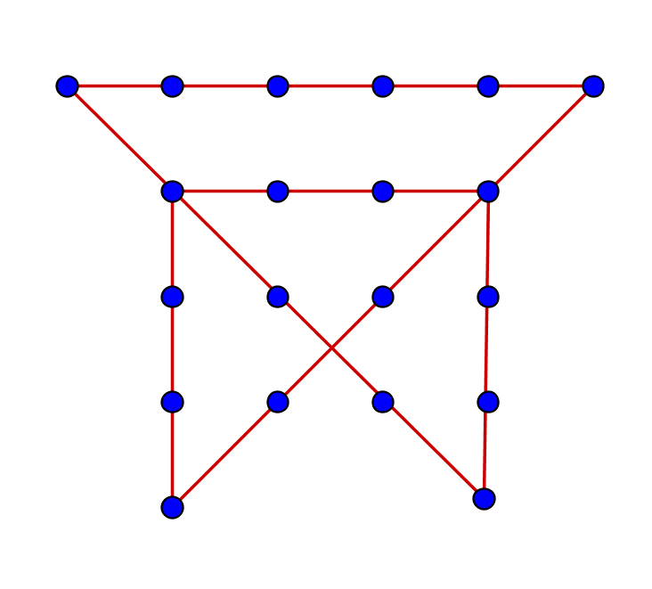

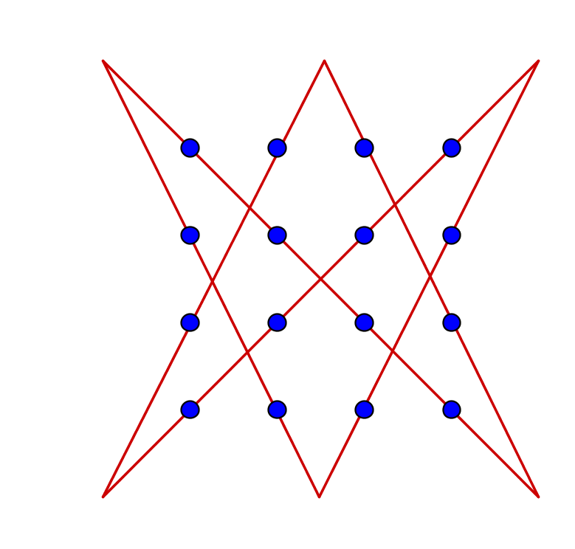

**Yue Kwok Choy**

**12/2/2016**